WE WANT TO PARTNER WITH YOUR BUSINESS!!
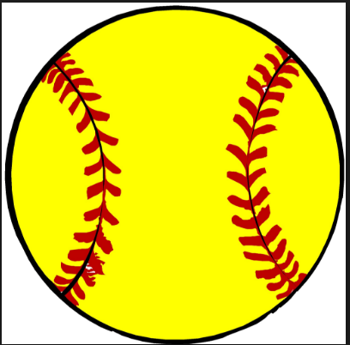 Single Sponsor-$200
- Your business will be announced during chosen innings at home games
- Corporate logo and link on team website
Double Sponsor-$300
- 1 Year outfield or wall sign
- Your business will be announced during chosen innings at home games
- Corporate logo and link on team website
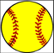 Triple Sponsor-$500
- 2 Years outfield or wall sign
- Your business will be announced during chosen innings at home games
- Corporate logo and link on team website
Homerun Sponsor-$800
- 3 Years outfield or wall sign
- Your business will be announced during chosen innings at home games
- Corporate logo and link on team website
Grand Slam Sponsor-$1500
- 1 Year scoreboard sign (5’x3” sign)
- Your business will be announced during chosen innings at home games
- Corporate logo and link on team website

*Grand Slam Sponsor has limited space. Please consult with Coach Cason to proceed.

Thank you for supporting the MVHS Softball Program!!
Tax Exempt Number: 27-0191298
Check out our website at: http://mvhsladybears.wixsite.com/mtnviewsoftball

Business Name: _______________________
Company Contact ______________________
Street Address: ________________________
City, State, Zip: ________________________
Phone:_________________________ Fax: _________________________________
Email: ________________________
Business URL (website address): ___________________________________________________
Player/Parent Name: ____________________________________________________________

Please indicate which level of sponsorship:
“Single” sponsor ___ Homerun sponsor ___
“Double” sponsor __ Grand Slam sponsor ___
“Triple” sponsor ___

Please make checks payable to Mountain View Diamond Club, Inc. (Sponsor Contributions can be given to any member of the Diamond Club.

Mountain View Diamond Club, Inc.
Tax Exempt Number: 27-0191298

Thank you for supporting the MVHS Softball Program!!
Check out our website at: http://mvhsladybears.wixsite.com/mtnviewsoftball

